Four steps Process for Star Schema Design:
Step 1: Select the Business Process.
The business process is Payments.
We focus on the payment process, which records financial transactions related to sales. Analyzing payments allows us to understand how much money is received, for which products, from which customers, when, and through which employees and stores.
Step 2: Declare the Grain.
The grain of the fact table is one payment.
Each row in the fact table represents a single payment transaction. This means that if a sale is paid in several installments, each payment is a separate row in the fact table. This level of detail allows us to analyze payments at the most granular level.
Step 3: Identify the Dimension.
DIM_PRODUCTS (Products)
PRODUCT_ID (PK): Unique identifier for the product.
PRODUCT_DESC: Name or description of the product.
CATEGORY_ID: Identifier for the product category.
CATEGORY_NAME: Name of the product category.
UPDATE_DT: Date when the product record was last updated.
Description: It allows to analyze payments by product and its category.

DIM_CUSTOMERS (Customers)
CUSTOMER_ID (PK): Unique identifier for the customer.
FIRST_NAME: Customer’s first name.
LAST_NAME: Customer’s last name.
EMAIL: Customer’s email address.
PHONE: Customer’s phone number.
ADDRESS_ID: Identifier for the customer’s address.
ADDRESS: Street address of the customer.
POSTAL_CODE: Postal code of the customer’s address.
CITY_ID: Identifier for the city.
CITY: Name of the city.
COUNTRY_ID: Identifier for the country.
COUNTRY_CODE: Code of the country.
COUNTRY_NAME: Name of the country.
REGION_ID: Identifier for the region.
REGION: Name of the region.
ECONOMIC_REGION_ID: Identifier for the economic region.
ECONOMIC_REGION: Name of the economic region.
UPDATE_DT: Date when the customer record was last updated.
Description: It allows to analyze payments by customer and their location (address, city, country, region, economic region).

DIM_STORES (Stores)
STORE_ID (PK): Unique identifier for the store.
MANAGER_ID: Identifier for the store manager.
ADDRESS_ID: Identifier for the store’s address.
STORE_ADDRESS: Street address of the store.
STORE_POSTAL_CODE: Postal code of the store.
STORE_CITY_ID: Identifier for the city where the store is located.
STORE_CITY: Name of the city where the store is located.
STORE_COUNTRY_ID: Identifier for the country where the store is located.
STORE_COUNTRY_CODE: Code of the country where the store is located.
STORE_COUNTRY_NAME: Name of the country where the store is located.
STORE_REGION_ID: Identifier for the region where the store is located.
STORE_REGION: Name of the region where the store is located.
STORE_ECONOMIC_REGION_ID: Identifier for the economic region where the store is located.
STORE_ECONOMIC_REGION: Name of the economic region where the store is located.
UPDATE_DT: Date when the store record was last updated.
Description: It allows to analyze payments by store, store location, and store manager.

DIM_EMPLOYEES (Employees)
EMPLOYEE_ID (PK): Unique identifier for the employee.
FIRST_NAME: Employee’s first name.
LAST_NAME: Employee’s last name.
EMAIL: Employee’s email address.
PHONE: Employee’s phone number.
ADDRESS_ID: Identifier for the employee’s address.
ADDRESS: Street address of the employee.
POSTAL_CODE: Postal code of the employee’s address.
CITY_ID: Identifier for the city where the employee lives.
CITY: Name of the city where the employee lives.
COUNTRY_ID: Identifier for the country where the employee lives.
COUNTRY_CODE: Code of the country where the employee lives.
COUNTRY_NAME: Name of the country where the employee lives.
REGION_ID: Identifier for the region where the employee lives.
REGION: Name of the region where the employee lives.
ECONOMIC_REGION_ID: Identifier for the economic region where the employee lives.
ECONOMIC_REGION: Name of the economic region where the employee lives.
STORE_ID: Identifier for the store where the employee works.
UPDATE_DT: Date when the employee record was last updated.
Description: It allows to analyze payments by employee and their location or store.

Step 4: Identify the Facts
FCT_PAYMENTS (Payments Fact Table)
CUSTOMER_ID (FK): References the customer who made the payment.
PRODUCT_ID (FK): References the product for which the payment was made.
EMPLOYEE_ID (FK): References the employee who processed the payment.
STORE_ID (FK): References the store where the payment was made.
SALES_ID (optional, FK or attribute): References the sale associated with the payment.
AMOUNT: The amount of the payment transaction.
SALES_DATE: The date when the payment was made.
UPDATE_DT: Date when the payment record was last updated.
Description: The fact table records each payment transaction. Enables analysis of payment amounts by product, customer, store, and employee. The grain is one payment (each row is a single payment event).

My justification for Retaining ID Attributes in the Star Schema
According to the assignment requirements ("Important note: It is crucial to retain all attributes and refrain from introducing any new attributes into the schema."), all attributes from the original 3NF schema must be retained in the star schema, and no new attributes should be introduced or existing ones removed. I guess this includes both business-relevant identifiers and technical or surrogate keys.
Category_ID
The attribute is preserved in the product dimension because it can be serves as a meaningful business identifier for product categories If it is not merely a surrogate key, but a natural identifier that may be used in reporting, integration, or business processes.
Address_ID, Country_ID, City_ID, Region_ID, Economic_Region_ID
While in classical star schema design these technical or surrogate keys are typically omitted in favor of denormalized descriptive attributes, in this case, they are retained strictly to comply with the assignment’s requirement to preserve all original attributes from the 3NF model.

Star schema

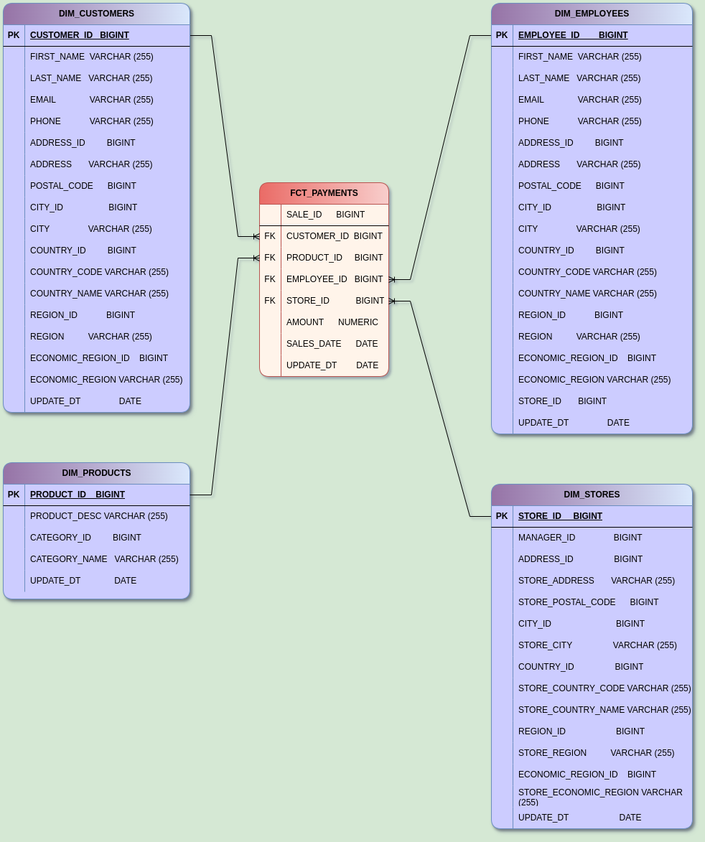

Description of normalization steps (from Star to Snowflake):
1. Identifying hierarchical dimensions: We take the denormalized tables from the Star (DIM_CUSTOMERS, DIM_STORES, DIM_EMPLOYEES, DIM_PRODUCTS) and search them for hierarchies (e.g., Address -> City -> Country, etc.).
2. Creating subdimensions: Repeated attributes (e.g., a city name that appears in many addresses) are moved to separate subdimension tables (DIM_CITY).
3. Replacing attributes with foreign keys: In the main dimension tables (DIM_CUSTOMERS, DIM_ADDRESS, etc.), the original attributes are replaced with foreign keys for the new subdimensions.

Snowflake schema
